Level E – Matchstick maths

Your Task: Complete a number of matchstick activities similar to the one completed in the algebra orientation. They need to have a table for each investigation and a rule.
Video- http://theglobalschool.net/maths/paE

Key Ideas:
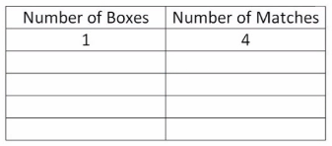

Rule: Number of match sticks Number of boxes x 3 + 1

Here are some investigations for you to conduct:
Number of stars | Number of lines
1 | 8
2 | 15
3 | 22
4 | ...
- | -
10 | ...

1.

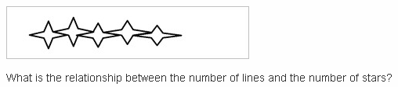
Rule:
- Fill in the table of values and find the rule
Rule: Number of match sticks Number of boxes x 3 + 1
Rule: Number of match sticks Number of boxes x 3 + 1
- Predict the number of lines in 10 Stars

2.
Number of Pentagons
1
2
3
4
- | -
10 | .

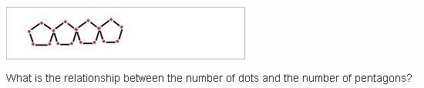
Rule:
- Fill in the table of values and find the rule
- Predict the number of dots in 10 Pentagons

3.
1
2
3
4
- | -
10 | .

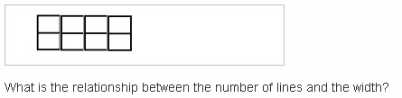
Rule:
- Fill in the table of values and find the rule
- Predict the number of lines in 10 rows

Your turn...

- | -
10 | .

4.

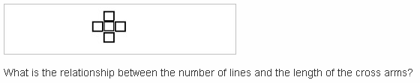

- Fill in the table of values and find the rule
Rule:
- Predict the number of lines in 10 cross arms

5.

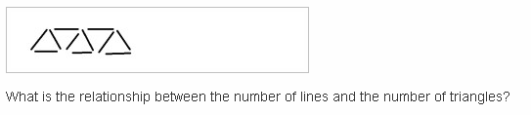
- Draw a table of values and find the rule
- Predict the number of lines in 10 triangles

